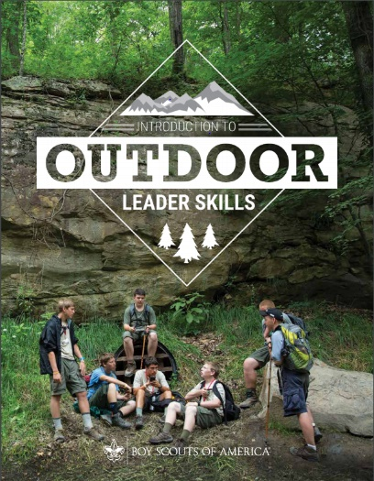
IOLS Training
November 10th (5 PM) – 11th (6 PM), 2023
Introduction to Outdoor Leaders skills

Presented by:
Cardinal District

Pre-Registration is Required, No Walk-Ins will be accepted.
Limited to 24 participants. No exceptions.

Deadline: November 2, 2023

Register and pay online at ocscouts.org/calendar

The Introduction To Outdoor Leaders Skills (IOLS) course builds and expands on the concepts and themes introduced in Scoutmaster Position-Specific Training and provides Scouters with the confidence to take youth into the outdoors. Specifically, this hands-on program gives adult leaders a practical introduction to the patrol method of a Scout-led troop by teaching many of the practical outdoor skills they need to lead Scouts in the out-of-doors.

NOTE: IOLS is required for all Scoutmasters, Assistant Scoutmasters, and Venturing Advisors to be considered BSA-trained in addition to the position-specific training for that position.

Location: Camp Agape 1369 Tyler Dewar Lane, Fuquay-Varina
Gathering: 5:00-5:30 - check in (please eat dinner before you come)
Training: 5:30 - 9:00 - Friday, 8:00 - 6:00 – Saturday
- Bring a tent, sleeping bag and personal gear.
- Breakfast and a “Trail Lunch” will be provided on Saturday.
- Pre-packaged snacks will be provided. Please indicate any food allergies or dietary restrictions when registering.

Course fee: $35.00 - which includes camp ground rental, Saturday breakfast, lunch, snacks, hand-out materials.
Questions? Contact Eddie Wilson at chefeddie68@gmail.com

